Are You In a Survey or Census?

[www.census.gov/survey_participants/](http://www.census.gov/survey_participants/)

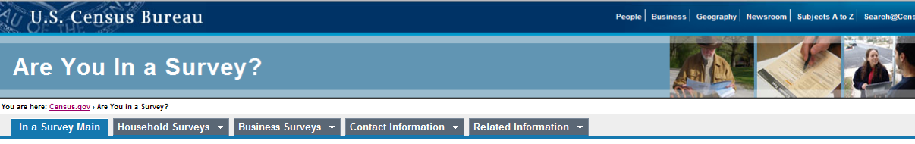

**Information for Survey and Census Participants**

The Census Bureau conducts a variety of censuses and surveys, not just the once-in-a-decade census. Every month, quarter, and year we conduct surveys with households and businesses. We use a workforce of trained federal employees to conduct a variety of household surveys by telephone and in-person interviews, as well as the mail.

d d t ith h h ld d b i W kf f t i d f d l l t d t

**We Protect Your Information**

The surveys we conduct provide information about social and economic conditions in the country, including employment, housing, manufacturing, trade, and many other topics. The questions we ask are used only to produce statistics, and you are never identified individually. For more information on how we protect your information, please see our Data Protection and Privacy Policy website:

[**www.census.gov/privacy**](http://www.census.gov/privacy)

**If someone from the Census Bureau has *visited***

**you and you have questions, please contact us:**

**Seattle Regional Office**

601 Union Street, Suite 3800

Seattle, WA 98101-1074

(206) 381-6200 or 1-800-233-3308

FAX: (206) 381-6310

TDD: (206) 381-6318

E-mail: [Seattle.Regional.Of](mailto:Seattle.Regional.Office@census.gov)[fice@census.gov](mailto:fice@census.gov)

**If you have received a *telephone call* from someone at the Census Bureau and you have questions, please contact the Census Bureau’s**

**National Processing Center**

**See reverse side for contact information.**

National Processing Center (NPC)

[www.census.gov/npc/contactus](http://www.census.gov/npc/contactus)

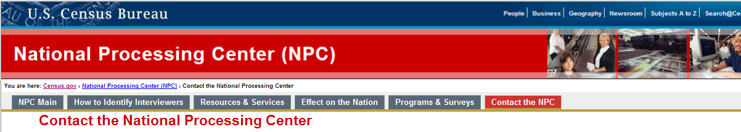

If you . . .

• want to verify that the person who called you is a Census Bureau employee,

• have a question about a survey form you received, or

• need to return a call about one of our surveys . . . Please contact us at one of these numbers:

• Hagerstown, MD: 1-800-392-6975

• Jeffersonville, IN: 1-800-523-3205

800 3205

• Tucson, AZ: 1-800-642-0469

Additional language specialties may be available.

If you have any questions about any of our telephone center operations, you can contact us via

[NPC.Call.Center.Info@census.gov.](mailto:NPC.Call.Center.Info@census.gov)

If you have not been contacted about a survey and are looking for general Census Bureau information, please call 301-763- INFO (4636) and they can better answer your questions. Thank you.

**U.S. Census Bureau**

**National Processing Center**

**1201 E. 10th Street**

**Jeffersonville, IN 47132**