U.S. Census Bureau Regional Offices

-DQXDU\ 201

AK

Seattle

WA

*Partnership and Data Services Program*

ME

FLDPDS/0DS-

**Phone Numbers for the Partnership and Data Services Program**

MT

ND

OR MN

ID SD WI

VT

NH NY MA

Boston

FOR YOUR DATA NEEDS

Atlanta

CA NV

MI WY Detroit

IA NE

Philadelphia

PA

CT RI

NJ

404-730-3833

**Boston**

Denver

UT

CO

Kansas

City

KS

Chicago OH IL IN

MO

KY

MD DE

WV DC

VA

NC

New York

617- - 10

Charlotte

Los Angeles

AZ NM

TN OK

AR SC

Atlanta

Charlotte

704- -

Chicago

Dallas MS

TX LA

HI

AL GA

FL

Puerto Rico

630-288-92 0

Dallas

214- - 8

Denver

720- -

**ATLANTA** - www .census.gov/atlanta

Alabama, Florida, Georgia

**BOSTON** - www .census.gov/boston

Connecticut, Maine, Massachusetts, New Hampshire,

New York (all counties except those covered by the

NY Regional Office listed under the state of NY),

Puerto Rico, Rhode Island, Vermont

**CHARLOTTE** - www .census.gov/charlotte Kentucky, North Carolina, South Carolina, Tennessee, Virginia

**CHICAGO** - www .census.gov/chicago

Illinois, Indiana, Wisconsin

**DALLAS** - www .census.gov/dallas

Louisiana, Mississippi, Texas

**DENVER** - www .census.gov/denver

Arizona, Colorado, Montana, Nebraska, Nevada,

New Mexico, North Dakota, South Dakota, Utah,

Wyoming

**DETROIT** - www .census.gov/detroit

Michigan, Ohio, West Virginia

**KANSAS CITY** - www .census.gov/kansascity Arkansas, Iowa, Kansas, Minnesota, Missouri, Oklahoma

**LOS ANGELES** - www .census.gov/losangeles Hawaii, Southern California (Fresno, Imperial, Inyo, Kern, Kings, Los Angeles, Madera, Mariposa, Merced, Monterey, Orange, Riverside, San Bernardino, San Diego, San Benito, San Luis Obispo, Santa Barbara, Tulare, and Ventura counties)

**NEW YORK** - www .census.gov/newyork

New York (Bronx, Kings, Nassau, Queens,

Richmond, Rockland, Suffolk, Westchester

DQG 1HZ <RUN FRXQWLHV)

New Jersey (Ber gen, Essex, Hudson, Morris, Middlesex, Passaic, Somerset, Sussex, Union, and Warren counties)

**PHILADELPHIA** - www .census.gov/philadelphia

Delaware, District of Columbia, Maryland,

New Jersey (all counties except

those covered by the NY Regional Office listed

under the state of NJ), Pennsylvania

**SEATTLE** - www .census.gov/seattle

Alaska, Idaho, Northern California (all counties

except those covered by the LA Regional Office

listed under southern California), Oregon,

Washington

Detroit

313-259-1875

Kansas City

913-551-6711

Los Angeles

818-267-17

New York

212- -3 0

Philadelphia

215-717-1820

Seattle

425-908-3060

: &DOGZHOO American Samoa, Commonwealth of the Northern Mariana Islands (CNMI), Guam, and the U.S. Virgin Islands

301-763-4033

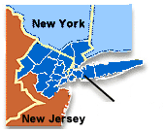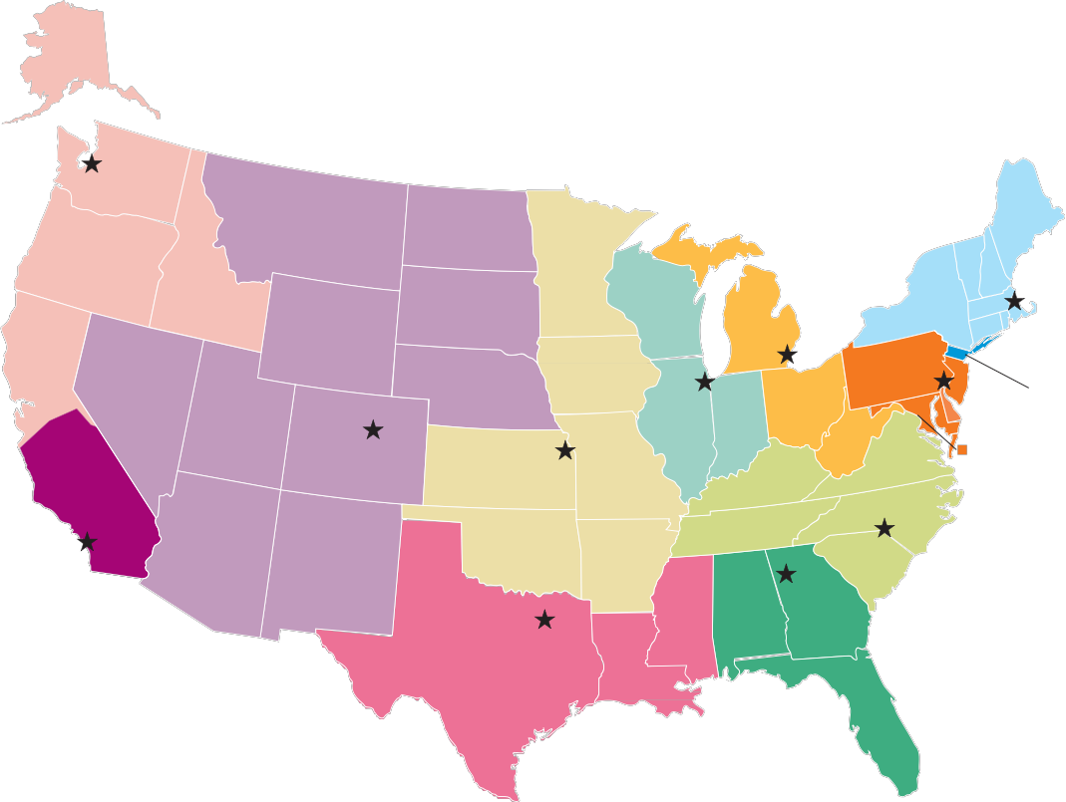

U.S. Department of Commerce Economics and Statistics Administration U.S. CENSUS BUREAU