**Data About Household Consumers**

**About the US Population**

Census Bureau statistics on the population of the United States are essential resources for small business. These data provide

information about consumer supply and labor markets that are key to business planning,

**Decennial Census**

2010.census.gov

information about the age, sex, race, ethnicity, relationship and housing tenure or the Nation’s population.

**American Community Survey (ACS)**

[www.census.gov/acs/www/](http://www.census.gov/acs/www/)

provides age, race, income, labor force, commute time to work, home value, veteran status, and other important data. The ACS collects and produces population and housing information every year instead of every ten years.

**Current Population Survey (CPS)**

[www.census.gov/cps/](http://www.census.gov/cps/)

the primary source of information on the labor force characteristics of the U.S. population.

Estimates include employment, unemployment, earnings, hours of work, and other indicators, available by a variety of demographic characteristics including age, sex, race, marital status, and educational attainment.

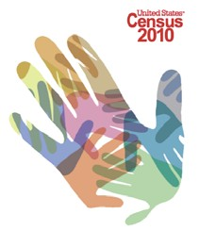

**Get help with a survey**

The Census Bureau takes a variety of steps to minimize reporting burden and simplify access to census and survey information.

Businesses can use the **Business Help Site**

at [www.census.gov/econhelp](http://www.census.gov/econhelp)

to get assistance with forms. Resources on this page describe each survey, provide sample forms, and permit extensions and other online services. A secure message center allows survey participants to communicate directly with survey sponsors.

**Find a Small Business Advocate**

**The SmallBizOmbudsman** [www.census.gov/eos/www/osbonew](http://www.census.gov/eos/www/osbonew) advocates for small business on topics that address reporting burden, facilitated reporting, improved data access. The Ombudsman seeks to educate small businesses on the significance of their data to the economy and the nation, and also to teach small business how the data they report can be used for their own benefit.

**Do Business With the Census Bureau**

**The Small Business Acquisition Specialist**

[www.census.gov/procur/www/sb](http://www.census.gov/procur/www/sb) serves as a liaison between the small business community and Census Bureau Acquisitions, ensures that the small businesses are provided fair opportunities within the federal government, and advocates for minority, small, disadvantaged, 8(a), HUBZone, veteran- owned, disabled and women-owned small businesses**.**

**Want to know more?**

All Census Bureau Economic Programs are available on the web at: [**www.census.gov/business**](http://www.census.gov/business)



**Census Bureau**

**Economic Programs** EC.09.01

[***www.census.gov/business***](http://www.census.gov/business)

**Census Bureau Resources For**

**Small**

**Business**

**Data About Businesses**

**A new website** business.census.gov shows businesses how they can use census and survey data to grow their business.

**The Business Size page** [www.census.gov/epcd/www/smallbus.html](http://www.census.gov/epcd/www/smallbus.html) data about employers and nonemployers, employment size of firms and establishments, and firms by receipt size.

**County Business Patterns**

[www.census.gov/econ/cbp](http://www.census.gov/econ/cbp)

annual information about establishments with paid employees: number of locations, employment, and payroll, by industry and by size, for the US, states, metro areas, counties, and ZIP Codes.

**Statistics of US Business**

[www.census.gov/econ/susb](http://www.census.gov/econ/susb)

annual information about the distribution of economic activity by business size: number of firms, number of establishments, employment, and payroll, by industry, for the US, states, and metro areas.

**Survey of Business Owners**

[www.census.gov/econ/sbo](http://www.census.gov/econ/sbo)

conducted every five years along with the economic census, breaks down businesses by industry and by owner characteristics such as sex, race, and ethnicity, for the US, states, metro areas, counties, and cities.

**Nonemployer Statistics**

[www.census.gov/econ/nonemployer](http://www.census.gov/econ/nonemployer)

annual information about businesses with no paid employees: number of businesses and receipts, by industry, for the US, states, metro areas, and counties.



Find more information inside

**Study Your Competition**

**Census Bureau Economic Programs** measure our vast and dynamic American economy for government and business decision- making and the public.

•  Monthly and quarterly indicators are critical to understanding current economic conditions.

•  Census and survey information provides authoritative information about small business and entrepreneurship that is essential to the economic development process in communities across the United States.

•  Data are published on the Internet and available in easy-to-navigate web pages including the American FactFinder online database

Census Bureau data are a primary resource for the Small Business Administration’s programs to encourage small business growth. *The Census Bureau does not define “small business” but provides size breakdowns so data users can construct their own size categories.*

**Economic Census**

[www.census.gov/econ/census07](http://www.census.gov/econ/census07)

Provides benchmark values every five years that update more frequent current surveys. Data include the number of establishments and firms, employment, payroll, and revenue:

•  **Geographic area reports** - businesses by industry for states, metro areas, counties, places, ZIP Codes.

•  **Product line reports** - sales of individual product lines, by industry, for states and metro areas.

•  **Establishment and firm size reports** - businesses by industry, and by size in terms of employment and revenue. Concentration ratios show contribution to industry output by the top 4, 10, 50, and 100 firms.



E-mail me when my industry or state is published

[www.census.gov/econ/census07/www/notifyme.html](http://www.census.gov/econ/census07/www/notifyme.html) Data from the 2007 Economic Census as it becomes available. Use “Notify Me” to get an email message when data for your industry or state is published!

**Benchmark Your Performance Industry Snapshots** business.census.gov

graphical tool to illustrate the data, and industry averages.

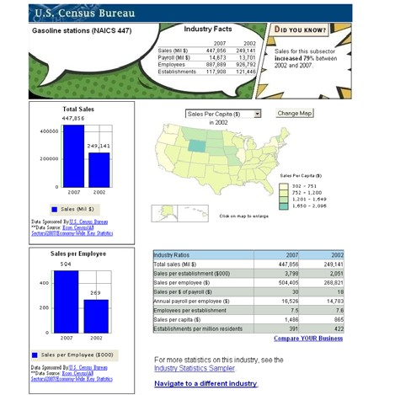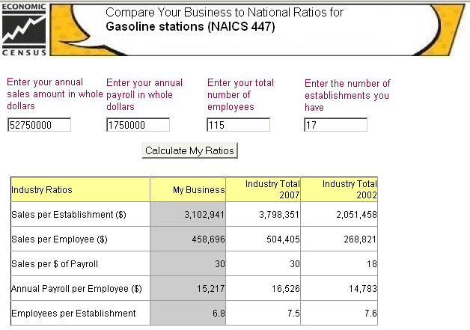

**Use “Compare Your Business” to benchmark your own data against industry metrics**

**Review Your Local Economy Economic Development Hot Reports** ced.census.gov

shows pertinent economic indicators in unified on- line reports from many data sources. These reports are useful for areas that experience economic disruptions due to natural disasters, plant closings, base closings, and other economic changes, such as abrupt increases in employment.

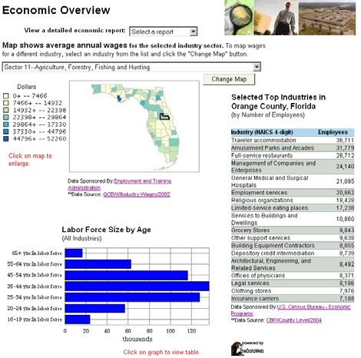

**Local Employment Dynamics**

lehd.did.census.gov/led/

provides local area profiles of local labor market conditions and geographic area analysis for very recent time periods.

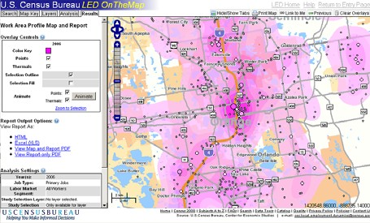

“On The Map” provides detailed maps showing where people work and where workers live.

**Get Data About Your Industry Industry Search** [www.census.gov/business](http://www.census.gov/business)

Use the Industry Search to find all census and current data about your industry.

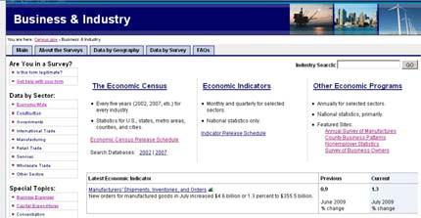

**Statistics About Governments**

[www.census.gov/govs](http://www.census.gov/govs)

provide monthly, quarterly, and annual information on state and local governments, including employment, revenues, spending, debt and assets. Federal government information includes employment by agency, along with spending by program and by state, county, and city.

**Foreign Trade Statistics**

[www.census.gov/foreign-trade](http://www.census.gov/foreign-trade)

provide monthly measures of imports and exports of more than 15,000 commodities, by port, by country of origin or destination, and by state of origin. Trade data provide essential information about business markets.