Industry Focus



What are the hot industries in your area? What does that industry’s workforce look like?

**Industry Focus** is a powerful analytic tool that quickly reports the top industries for your area, your age group or gender, based on eight quarterly workforce indicators:

• employment

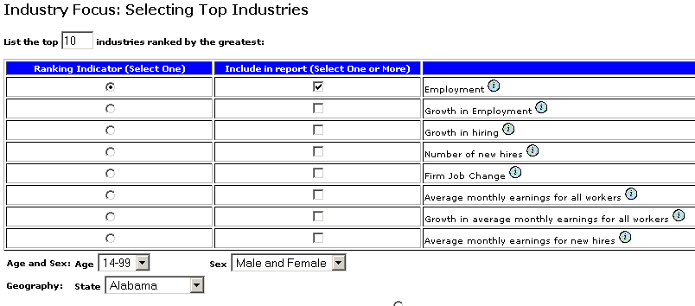

• growth in employment

• growth in hiring

• number of new hires

• firm job change

• average monthly earnings for all workers

• growth in average monthly earnings for all workers

• average monthly earnings for new hires

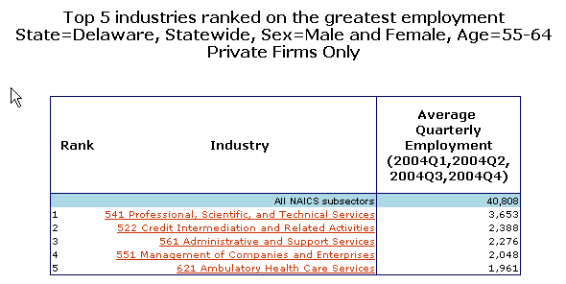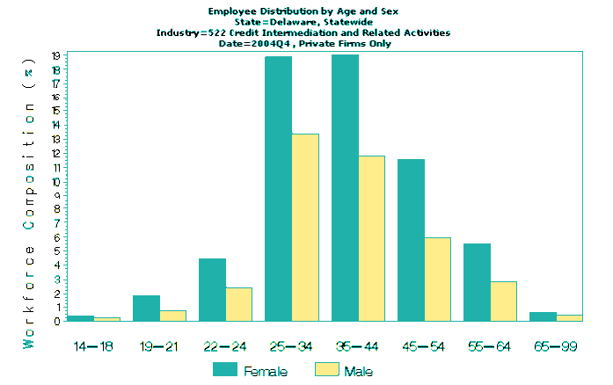

***Industry Focus*** *allows you to select an age group, gender and level of geography: statewide, county, workforce investment area or metropolitan area.*

You can learn more about the workforce for that industry with a single click.

*The report shows the top industries in Delaware employing workers aged 55-64 (excluding federal/military employment.)*

**Industry Focus** is one of the three tools that the **Local Employment Dynamics** program offers on its website for use by economic developers, employers, workers, transportation planners and workforce investment boards.

**Local Employment Dynamics** is a voluntary partnership between states and the federal government to share and enhance workforce data. To date, 43 states have joined the

partnership and data from 37 states are available free online at [http://lehd.dsd.census.gov](http://lehd.dsd.census.gov/).

For more information, email [dsd.local.employment.dynamics@census.gov](mailto:dsd.local.employment.dynamics@census.gov)



*Clicking on a hyperlinked top industry brings up a bar chart showing the composition of the workforce for that industry, by age group and gender, and other workforce measures.*

IF 061023