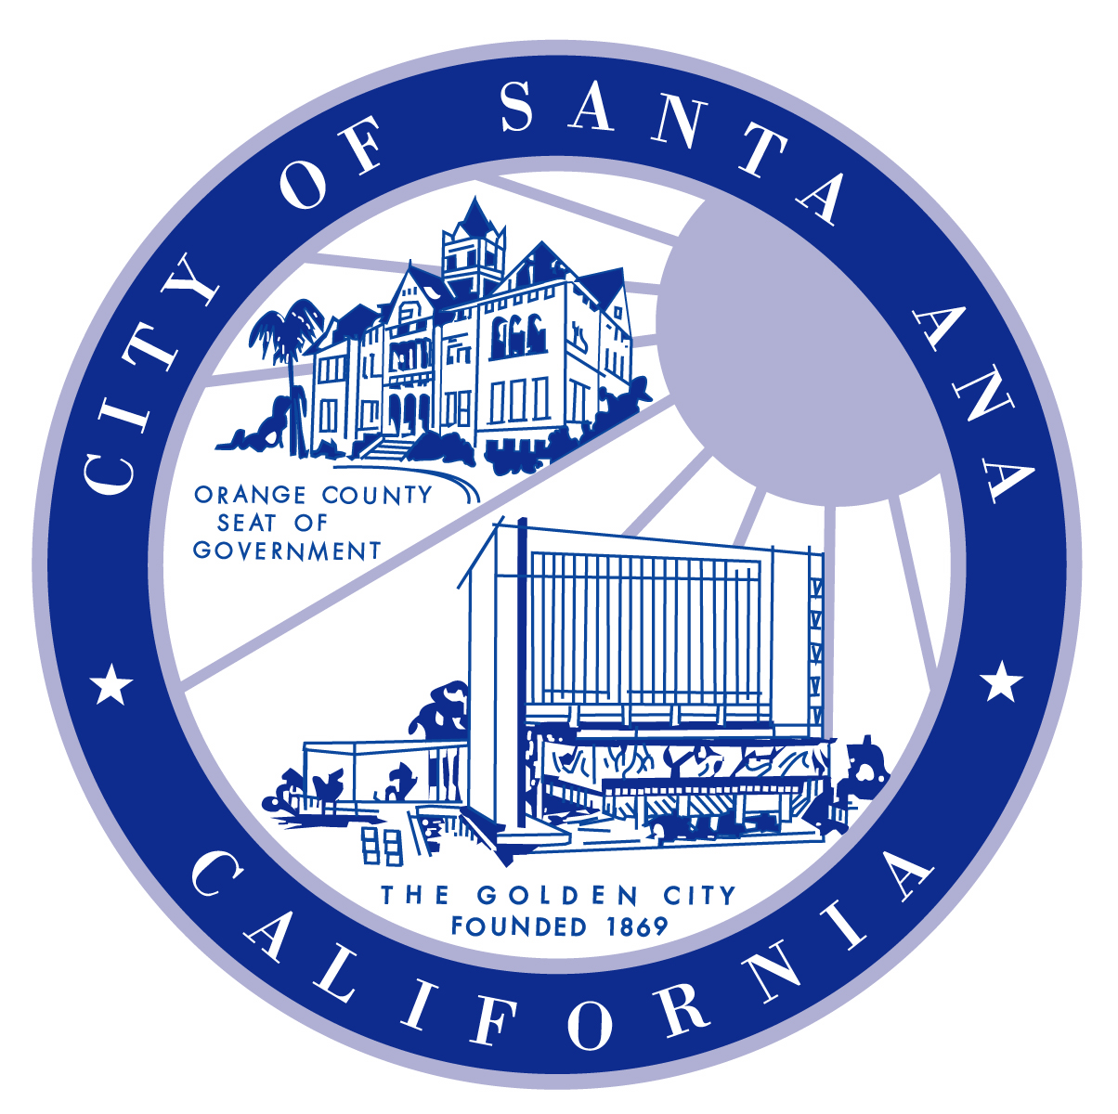
CITY MANAGER
David N. Ream
CITY ATTORNEY
Joseph W. Fletcher
CLERK OF THE COUNCIL
Patricia E. Healy
MAYOR
Miguel A. Pulido
MAYOR PRO TEM
Carlos Bustamante
COUNCILMEMBERS
Claudia C. Alvarez
David Benavides
Michele Martinez
Vincent Sarmiento
Sal Tinajero

CITY OF SANTA ANA
LIBRARY
26 CIVIC CENTER PLAZA

SANTA ANA, CA 92701
March 11, 2009

California Pizza Kitchen, Manager
Main Place Mall
2800 N. Main Street, #872
Santa Ana, CA 92701

Dear Sir or Madam:

The Santa Ana Public Library is gearing up for a summer of fun reading for children and families in Santa Ana. Our 2009 Summer Reading Program with the theme “Home Run Readers” will run for six weeks, beginning June 19 through August 1, 2009. We are writing to request your assistance and sponsorship to this program to make it an exciting activity for our youth this summer.

The purpose of the Summer Reading Incentive Program is to encourage children and teens, Pre-school to 12th grade, to read during the summer. With reading incentives, students are more motivated to continue reading outside of school, which will help retain and improve their reading skills as well as develop a positive attitude toward reading and books. Participating students receive small prizes for reading a required number of books. In addition, those who complete the entire reading requirement will be entered into the grand prize raffles for better prizes.

Every summer, the Santa Ana Public Library reaches out to thousands of youth in the community. These youth will be ready to begin a new school year in September with stronger reading skills and greater academic preparation.

As the economy worsens and funding is severely limited, we mostly depend on the generous support of community partners and sponsors to keep this essential program going. We hope to receive your continued support this year as you have generously given us in the past. Please help us continue to provide this worthwhile service to our needy children. We are grateful for any donations, large or small, that your restaurant can offer. Donations can be sent to: Santa Ana Public Library, Youth Services, Attention: Supervising Librarian, 26 Civic Center Plaza, Santa Ana, CA 92701

Monetary donation can be made out to the “Friends of the Santa Ana Public Library”, Attn: Youth Services, Summer Reading Program. All prizes & donations will be raffled at the end of the program for those who complete the reading requirements.

Thank you very much for being a part in this important effort to help promote reading to Santa Ana youth. If you need more information on the reading program or other library services, please call me at (714) 000-0000 or email me at -------

Sincerely,

Supervising Librarian
Youth Services

